

Bank Queue Management System

Created by

Mohammed Rajhi | Drashti Patel

COS 506: Advanced Programming / Data Structure

April 25, 2017

The fundamental goal of our project was to build an online bank management system that automates all the banking processes, thus providing a user-friendly interface for clients. By automating the bank process, any information related to the user can be searched easily as well as it can help maintain data effectively and efficiently. In our banking system, four main features are displayed on our menu screen. They are: open a new customer account, view details of an account by logging in to the system (with a username and a password), ask for assistance, and logout of the system. In addition, it only allows authorized clients to access different functions/processes that are available within the system as our system is password protected to lessen security fraud. Furthermore, users can manage all bank account activities by selecting one of the following options:

* User menu options
* Create an account
* View current account balance
* Search a particular account holder details
* Delete an account
* Add funds to an account
* Withdraw funds from an account
* Ministatement of all transactions made on an account
* Transfer funds from one account to another account
* Put funds as a fixed deposit on an account (along with the interest rate of 6%, 8%, and 10%)
* View a fixed deposit on an account
* View transactions made by the user
* Update an account by providing new information

Clients can also manage the following account types: savings account, current account, fixed deposit account, and other account. The project considered all the above-mentioned features to meet the requirements of an arbitrary bank.

Please refer to the bank queues system zip folder to access the specification and implementation files. To demonstrate all the above features, screenshots of the program output are displayed on the next page, step-by-step along with the guidelines.

Screenshots of the Program Output: Walk Through Step-by-Step

* Bank management system “Welcome Screen” is shown with the main menu screen consisting of four options.

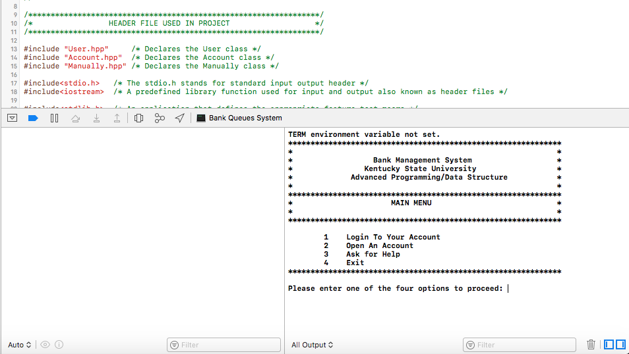

* First, select option 2 to open an account.

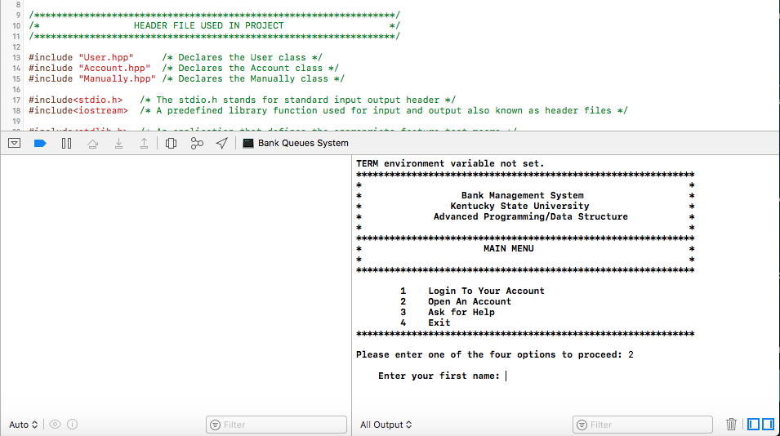

* Enter personal information such as, first name, last name, 10-digit phone number, date of birth, and account type.

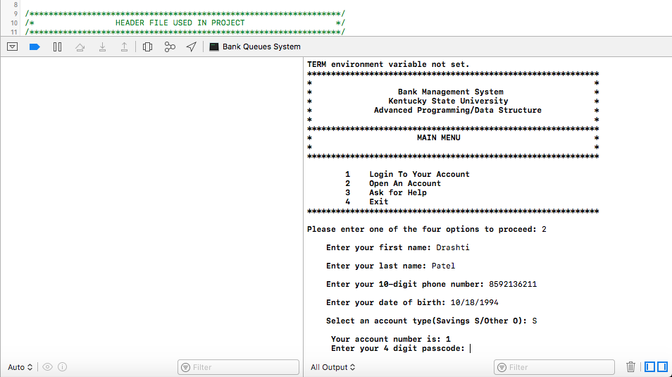

* Type in any 4-digit (numbers) as a passcode to proceed further. For example: 5861.

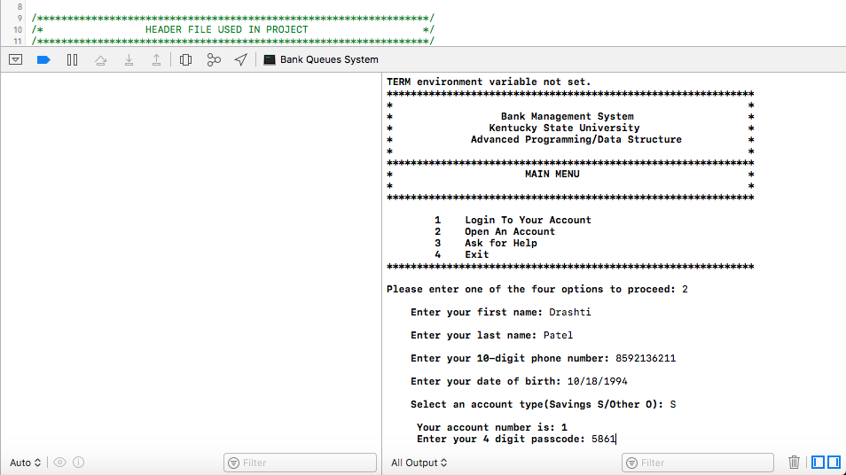

* Now, enter the primary balance. For instance: $100.

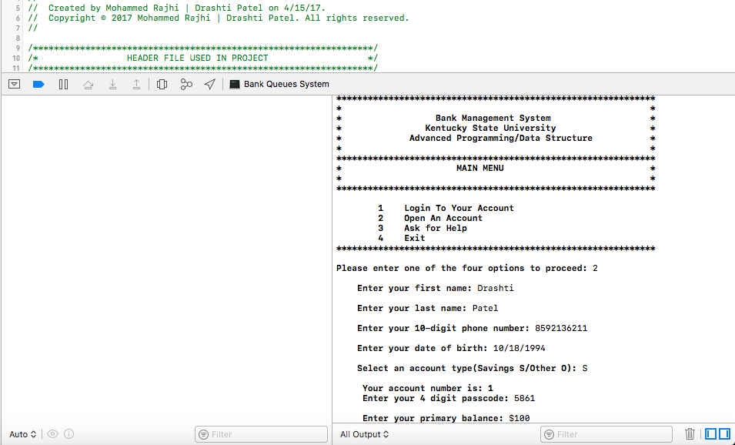

* At this stage, the account number, passcode, and primary balance has been assigned to the user (i.e. Drashti Patel). In other words, an account has been created successfully for this user and the screen will return to the home page.
* To proceed further, log into an existing account that was created.
* Select option 1 to login in an account
* Insert account number as 1
* Insert 4-digit passcode as 5861.

By following these steps, the login is successfully done!

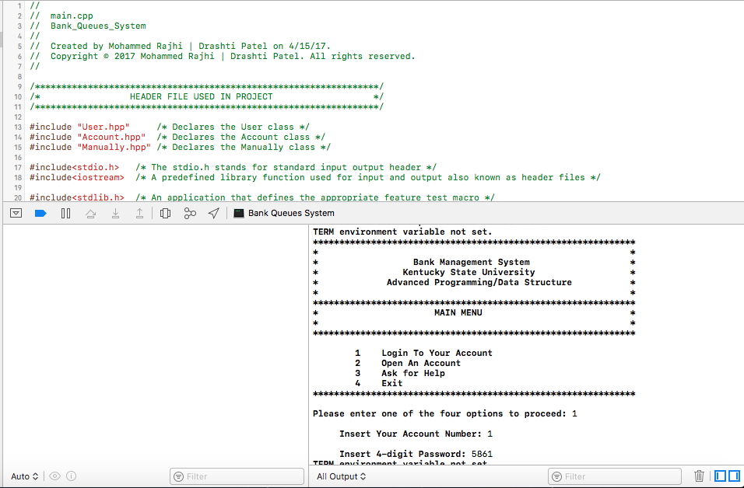

* The login screen will appear along with the account number. In this case, it is 1. Along with the several options / features this system offers. Let’s start by going through each option one by one.

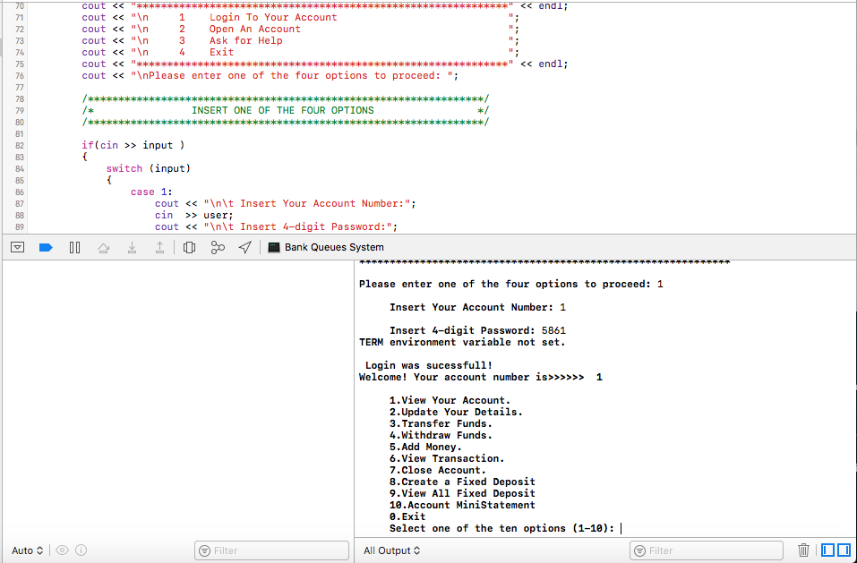

* Select option 1 to view the account details. The account details will be displayed that consists of account number, name, phone, date of birth, account type, and balance.

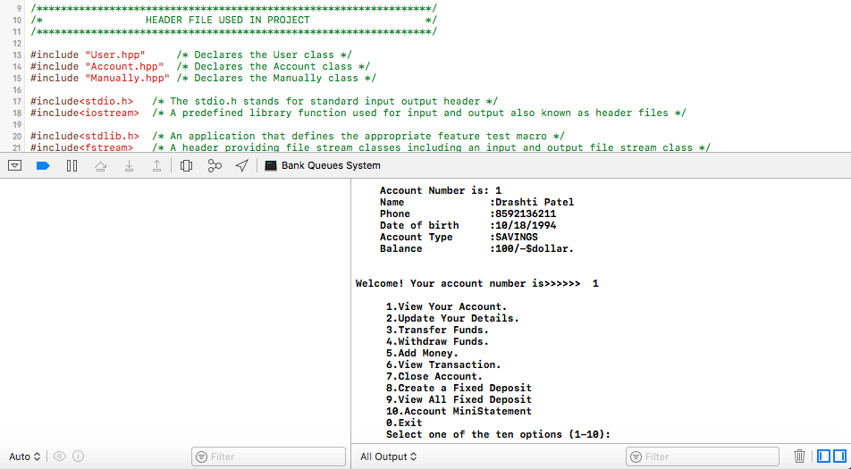

* Enter option 2 to update the details of an account. Enter the same first name, last name, phone number, date of birth, and account type. After entering the same information, the system will display that no changes have been made (since we did not change any of the information). By entering different account information, account changes will be made accordingly.

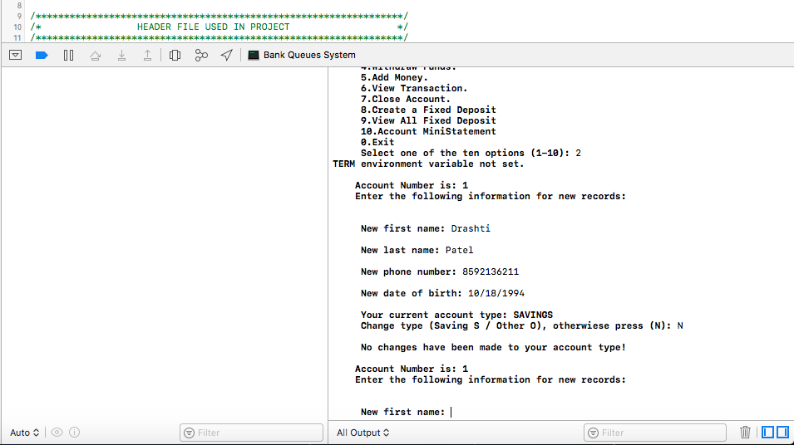

* Enter option 3 to transfer funds from your account to your friend’s account by providing his or her account number. Here, a friend’s account number is 4 and $100 has been transferred to his or her account.

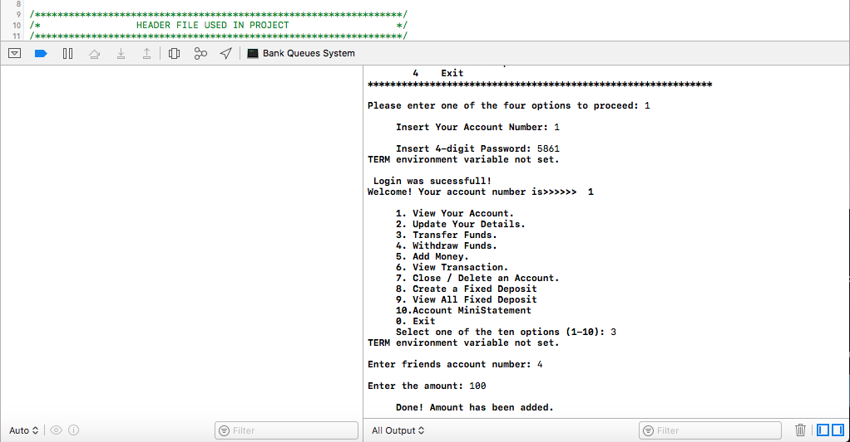

* Enter option 4 to withdraw funds from an account. Let’s withdraw $50 from an account number 1.

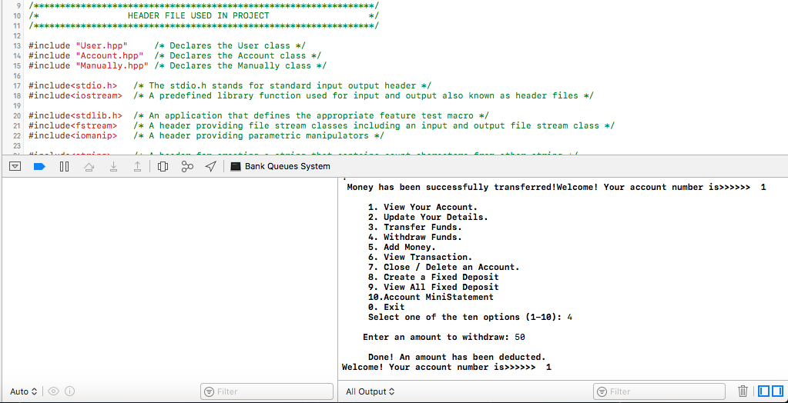

* Select option 5 to add funds to an account. Let’s add $200 to an account. The current balance is now $250.

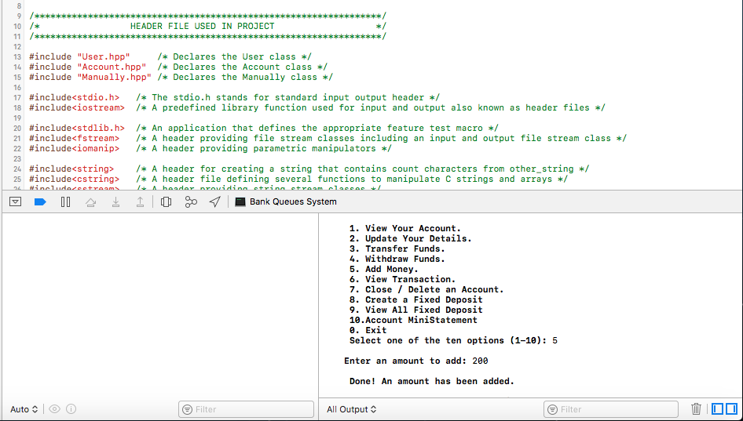

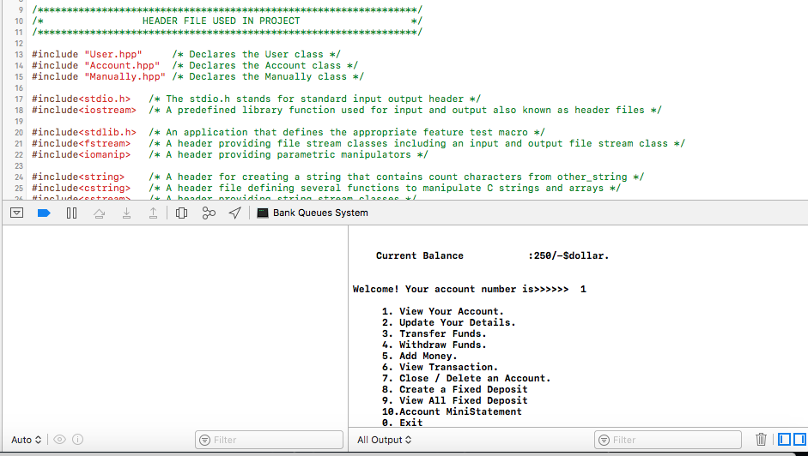

* Select option 6 to view transactions of an account.

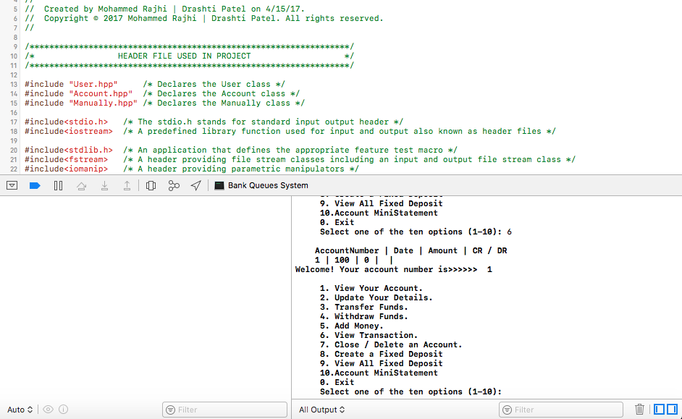

* Enter option 7 to close/delete an account from the system. Enter first name and last name to delete an account.

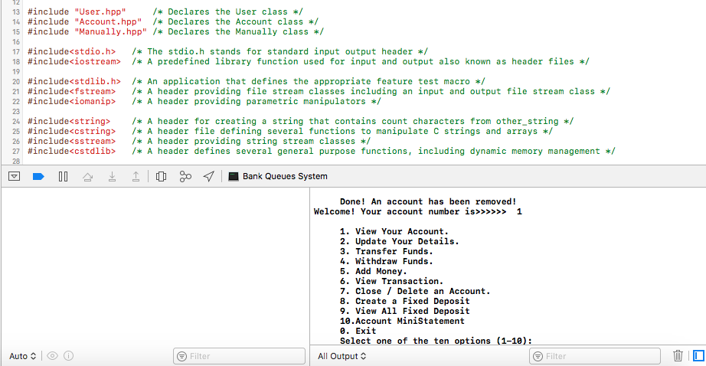

* Enter option 8 to create a fixed deposit account along with the interest rate.

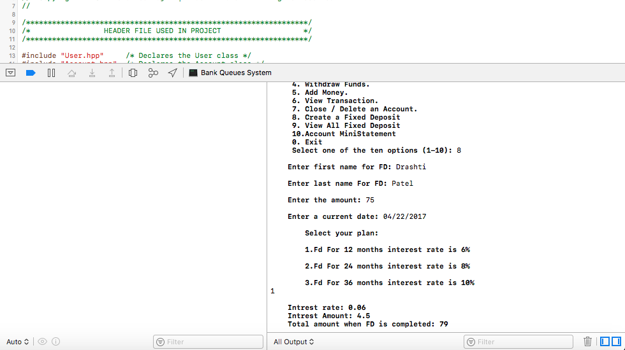

* Enter option 9 to view the fixed deposit account.

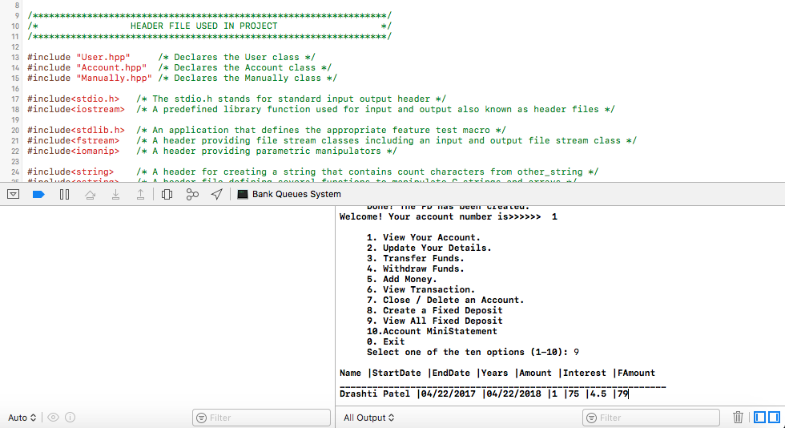

* Enter option 10 to view the account mini-statement.

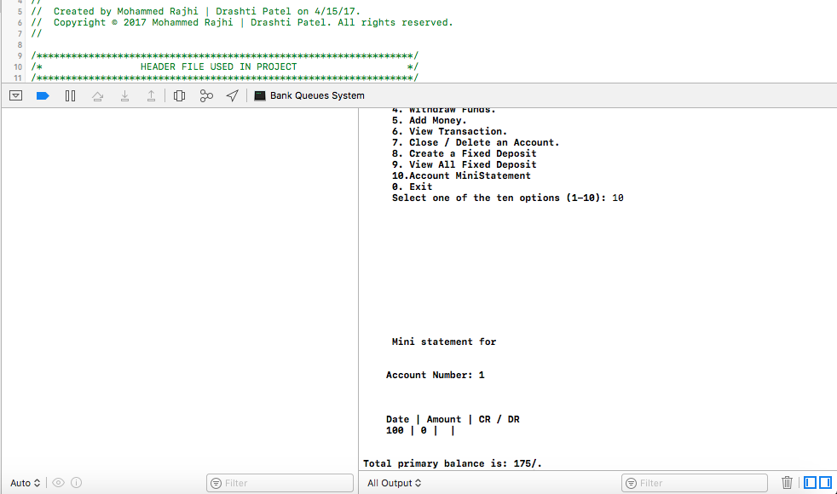

* Lastly, select option 10 to exit out of the system.

Overall, this bank management system provides a secure system and is more efficient, reliable, and user-friendly.